**MyDBMI Content Management**

How-to Guide for Common MyDBMI Content Management Tasks

* MyDBMI: This help doc is limited to changes on the production MyDBMI server.
* Platform/Server: Windows, Linux
* URL: <http://my.dbmi.pitt.edu/>
* Admin login URL: : <http://my.dbmi.pitt.edu/>
* Contact: [Melissa Schwenk](mailto:mds127@pitt.edu?subject=MyDBMI%20User%20Guide)
* Site Maintainers: DBMI at the NOC

**Task 1: Editing/Adding a Seminar/Lecture – For Training Program:**

The training program administrator (Toni Porterfield) will send weekly updates for the Training Program Seminar that is held on Fridays at 11AM. On the public DBMI site, the schedule is created at the beginning of the semester and individual seminars are created and added even though they hold “To Be Determined” information that is filled in each week. On MyDBMI, the seminars are added weekly and appear on the MyDBMI event calendar.

1. Login to MyDBMI
2. Go to the black admin menu at the top of the page and select the Content->Add Content option and select the Seminar content type, OR go to https://my.dbmi.pitt.edu/node/add/seminar and fill in the appropriate information. Make sure that you enter the date of the lecture/seminar. This is what determines whether or not the seminar appears on the MyDBMI public calendar on the top of the right-hand column.
3. Save the changes to the Seminar node.
4. Go back and check the calendar to make sure that the new seminar appears.

**Task 2: Editing/Adding News Items:**

On MyDBMI , there is a custom content type called News. “News” is a catch-all category that includes the following sub-categories :

Administrative



IT



People



Congratulations



Funding Opportunities



Job Opportunities



Publication



Article of the Month



News items appear on the front page of the site once they are added in a stream of short teasers of information. Behind the scene, each different type of news item has its own page that shows only items of a particular sub-category. They can be found by going to DBMI News in the main horizontal menu.

The News content type has two main fields. The top field, labeled “Front Page Brief” allows you to enter a brief version of the news item. Keep this to around 3 lines. You may include small images in this section or links to articles and web pages. You may want to add a “Read More” link to this field that goes to the full content node.

The second field is labeled “News Content” and it holds the full text of the news item as well as links and images that are part of the news.

**Examples of how to categorize news items:**

NIH Announcements go under Funding Opportunities

Articles of the Month go under Article of the Month

CTSI Announcements go under Administrative News

Job Announcements go under Job Opportunities

Baby birth announcements go under Congratulations

Student accomplishments go under People

General Office announcements go under Administrative News

**Steps to create a News item:**

1. Select the category you will use for this news item.
2. Go to Content ->Content->Add Content->News
3. Make sure you select an option in the “News Type” field
4. Add a brief “teaser” in the “Front Page Brief” field

**(In both the “Front Page Brief” field and the “News Content” field, select “Full HTML” under the Text Format option so that you have full control over formatting the text. )**

1. If you need this item to be displayed on the DBMI Calendar, you must enter the date/time of the news item in the “Date of News Event”.
2. Submit the changes/additions and check the front page to see if the news item appears as intended.

**Steps to edit a News item:**

1. Go to the item you want to edit by selecting the top Content link on the admin menu. You may use the filter to select items of a certain type. Once you find the particular news item, click on the link or edit button and make any changes.
2. Save and verify the changes.

**Task 3: Uploading Items:**

Images, files, links and documents may be embedded within text in most DBMI content types. When you are embedding these items, make sure that your text editor is using the “Full HTML” format because this gives you access to extra functionality that includes browsing for files on your PC, easy link creation and image configuration.

**Steps to Add an Image:**

1. In the “Full HTML” mode of the item that you are adding/editing, put your cursor where you want to add an image.
2. Select the Image icon from the editor tool bar:



1. In the Image Properties dialog box, select “Browse Server”.

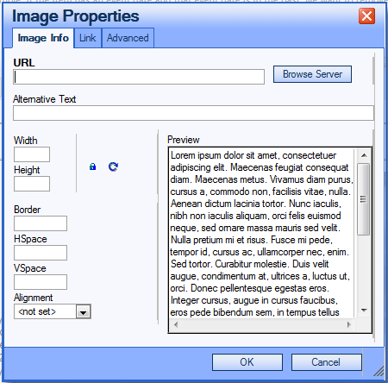

1. In the file browser dialog, if the image has already been uploaded to the MyDBMI server, select it from the list of files on the right in the browser. If you need to upload a new file, select the upload link in the editor.

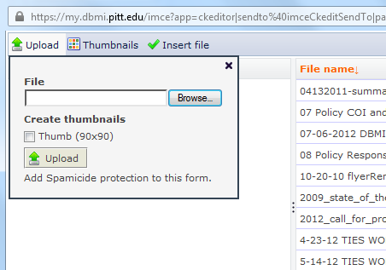

1. Find the file you want to upload on your own computer and select upload. The uploaded file should appear in the list of files on the right. Select the file and click on “Insert file” to upload it to the page you are editing.
2. You can adjust the size of the image in the Image Properties dialog by changing the Width and Height fields. If you change the width, it will automatically change the height so the image proportions remain intact.
3. Save the Image Properties by selecting OK and check to see if the image is where it should be.
4. Continue editing and save.

**Steps to Add a File (any file – pdf, PowerPoint, Word etc.):**

1. In the “Full HTML” mode of the item that you are adding/editing, put your cursor where you want to add an image.
2. Select the Link icon from the editor tool bar:



1. In the Link dialog box, select “Browse Server”.

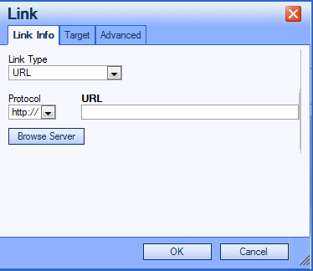

1. In the file browser dialog, if the file has already been uploaded to the MyDBMI server, select it from the list of files on the right in the browser. If you need to upload a new file, select the upload link in the editor.



1. Find the file you want to upload on your own computer and select upload. The uploaded file should appear in the list of files on the right. Select the file and click on “Insert file” to upload it to the page you are editing.
2. Save the Link by selecting OK and check to see if the file has been uploaded and linked.
3. Continue editing and save.

**Steps to Add a Link :**

1. In the “Full HTML” mode of the item that you are adding/editing, highlight the text where your link will be added.
2. Select the Link icon from the editor tool bar:



1. Type or cut and paste the URL that you need to link to OR select “Browse Server” to link to an existing file. In the Browse Server window, you can also upload a new file if needed.



1. If the link is going to a URL that is outside of the MyDBMI site, it is best to set the Target field to “New Window (_blank)”. This makes sure that the link opens in a new browser window so the user doesn’t lose the focus on the MyDBMI site. Click on the “Target” tab and select this option from the dropdown menu.

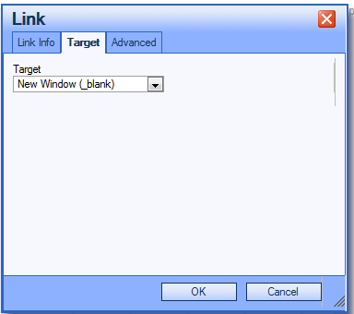

**Task 4: Common Editing Issues**

The Text Editor that is used for all MyDBMI content management may not produce the formatting that you are expecting. Below are several tips for common problems.

1. **There are too many blank lines below the text area.**

Solution: Remove any extra carriage returns in the Text Editor. Go to the bottom of the text and backspace until you come to the end of the actual text. Save.

1. **You want more control over the position of text and images**.

Solution: Creating a table allows you to specify the position of cells. For example if you want to put text on the left and images on the right, create a table with one row and two columns. Add text into the left cell and images into the right cell.